“全省安全用药月”宣传推广总结

附：相关推广截图及链接
1、微博
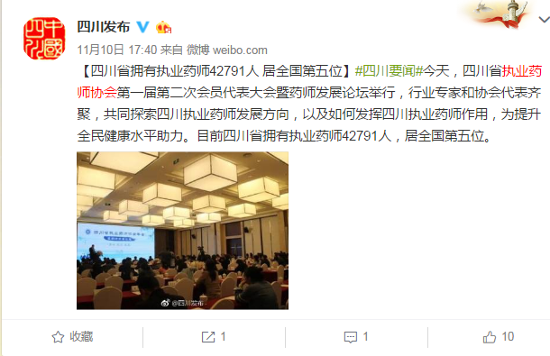
https://weibo.com/1905843503/FusrrAXBH?from=page_1001061905843503_profile&wvr=6&mod=weibotime
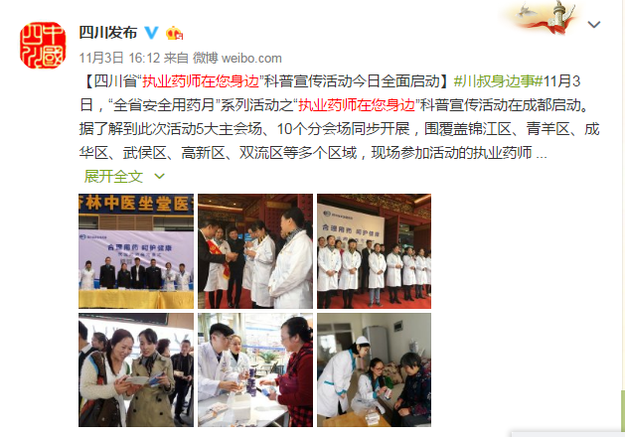
https://weibo.com/1905843503/FtnS1l3MG?from=page_1001061905843503_profile&wvr=6&mod=weibotime
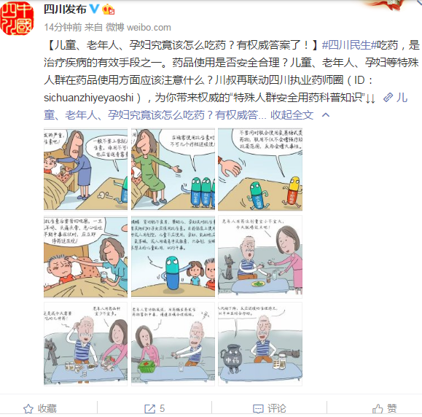
https://weibo.com/1905843503/FuTBpsvjz?ref=home&rid=3_0_8_2596567378476496484

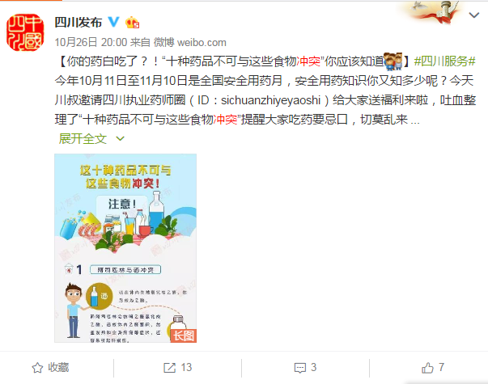
https://weibo.com/1905843503/FsbWt2Nvp?from=page_1001061905843503_profile&wvr=6&mod=weibotime

2、微信
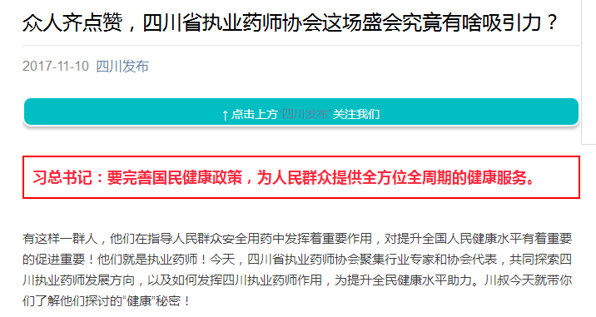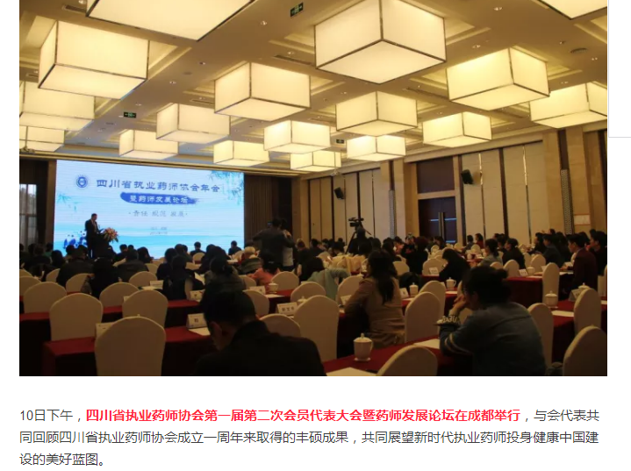
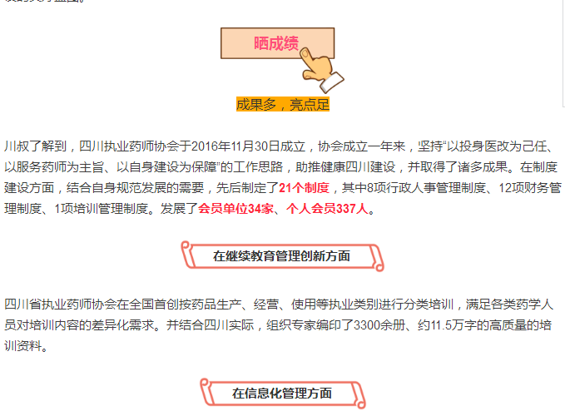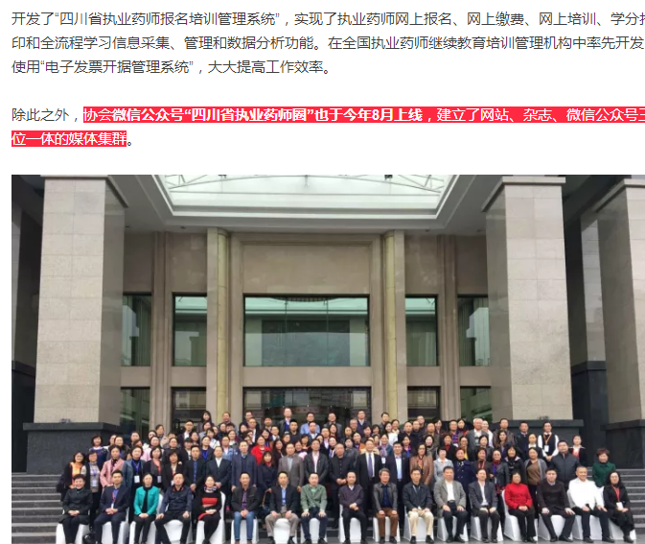
https://mp.weixin.qq.com/s?__biz=MzA3MDA4MTgyOA==&mid=2654914578&idx=3&sn=9d6d4453ef1a25f3ab159c2a710cae15&chksm=85082459b27fad4f63baacb864801508685257f86e7062958d0ee5fb5df85f360ad6d6f11158&mpshare=1&scene=23&srcid=11132qWrDr8hi6vFtD1q91lZ#rd
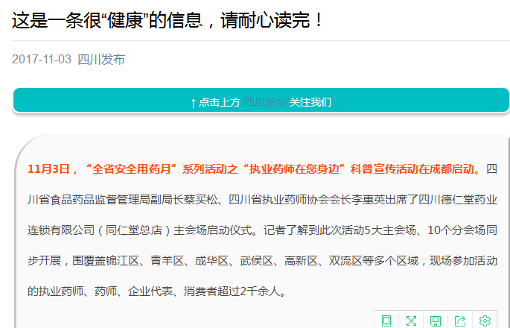
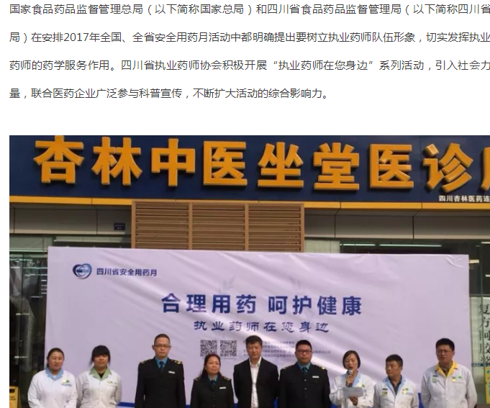
https://mp.weixin.qq.com/s?__biz=MzA3MDA4MTgyOA==&mid=2654914403&idx=2&sn=ff8fcb9c8a468c981c244d73ff4d126b&chksm=85082b28b27fa23e5db2c066710e92bcf9e5c11282cf19cfe1366a3d5a9a661d2d89420d7600&mpshare=1&scene=23&srcid=1113mPpqsvJmMgtLeVY6J8xg#rd

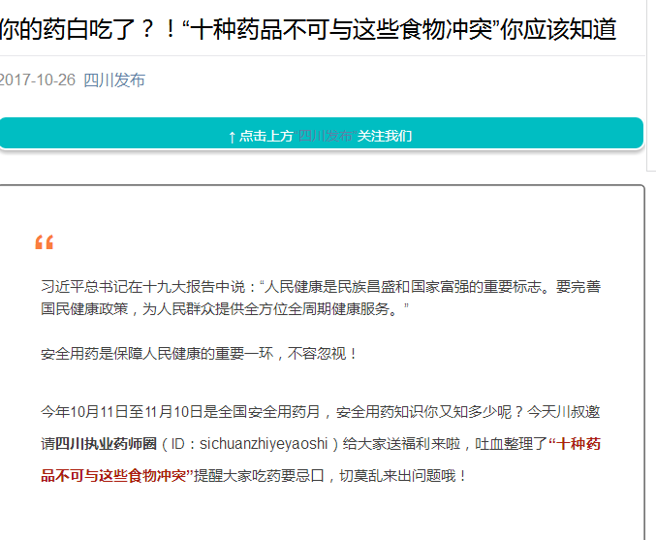
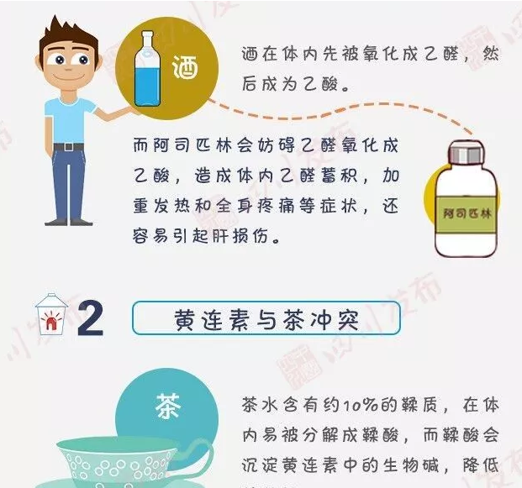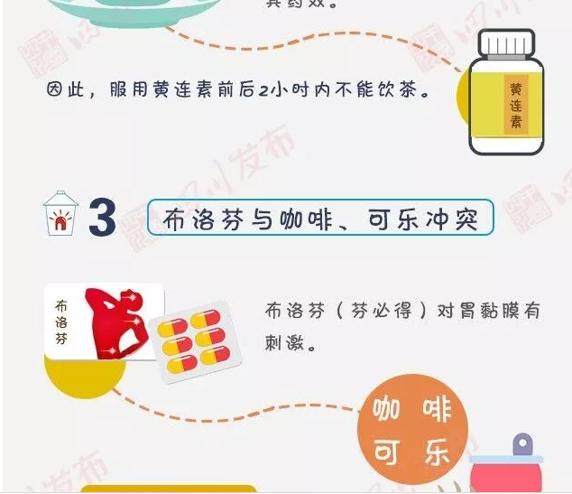
https://mp.weixin.qq.com/s?__biz=MzA3MDA4MTgyOA==&mid=2654914172&idx=3&sn=15680041f6f319a31a6758d20767bd8e&chksm=85082a37b27fa321d77c9e4d65e02cca4422e8af45c9756f7c31d6f1a772b42219667b25084f&mpshare=1&scene=23&srcid=1026RUnVnuokLh6ezNilgHvV#rd
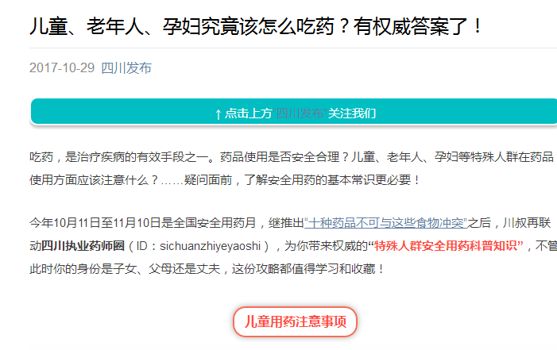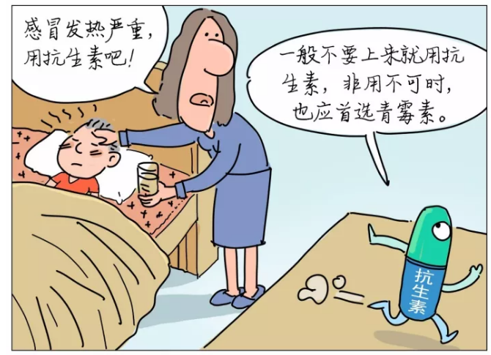
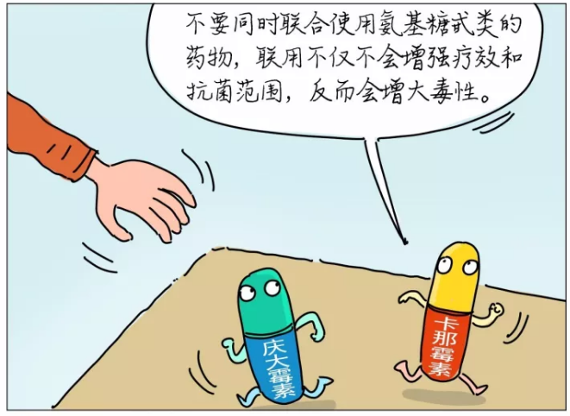
https://mp.weixin.qq.com/s?__biz=MzA3MDA4MTgyOA==&mid=2654914274&idx=3&sn=77e8e0adfa1bf7510cc2ff41a0ba82cc&chksm=85082aa9b27fa3bfad928c950ad48069b67b28c410aad3cf692717f533021fdb5bf45046f18d#rd

3、四川发布客户端
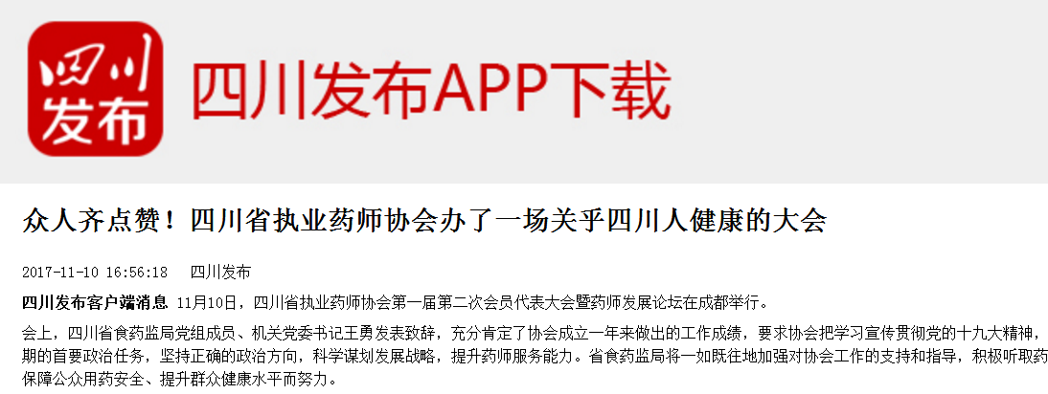
http://appweb.scpublic.cn/news/wx/detail?newsid=78769&time=1510542623466
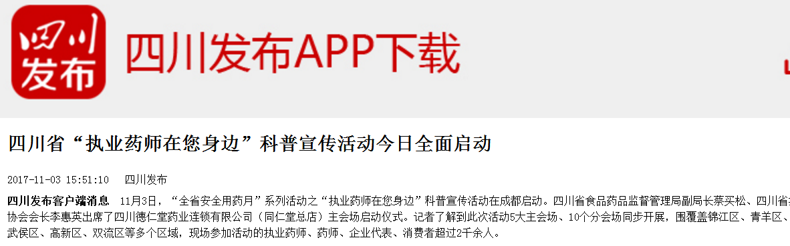
http://appweb.scpublic.cn/news/wx/detail?newsid=77842&time=1510542640993
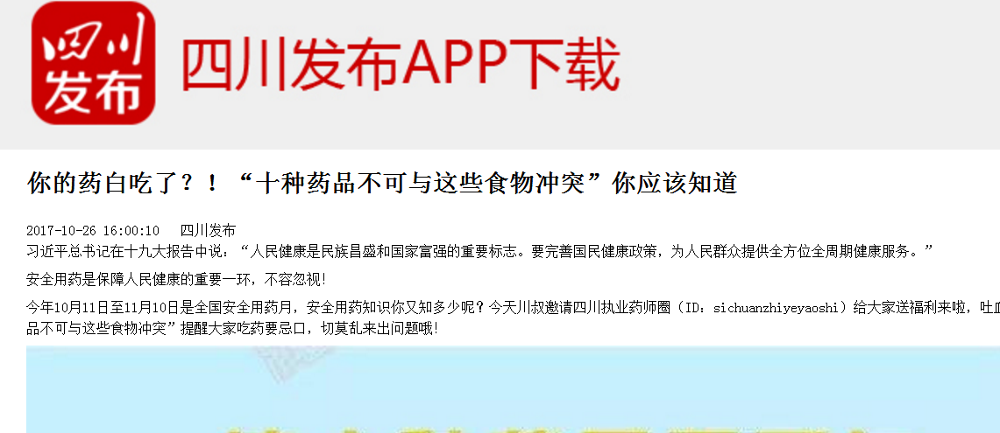
http://appweb.scpublic.cn/news/wx/detail?newsid=76558&time=1510542451740
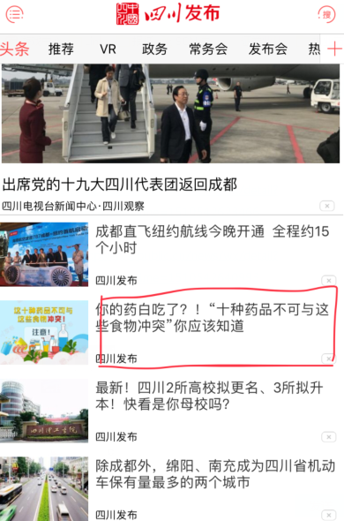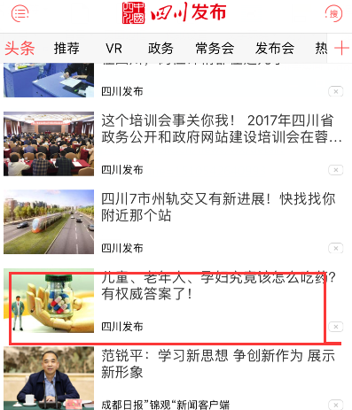

https://mp.weixin.qq.com/s?__biz=MzA3MDA4MTgyOA==&mid=2654914274&idx=3&sn=77e8e0adfa1bf7510cc2ff41a0ba82cc&chksm=85082aa9b27fa3bfad928c950ad48069b67b28c410aad3cf692717f533021fdb5bf45046f18d#rd

4、今日头条
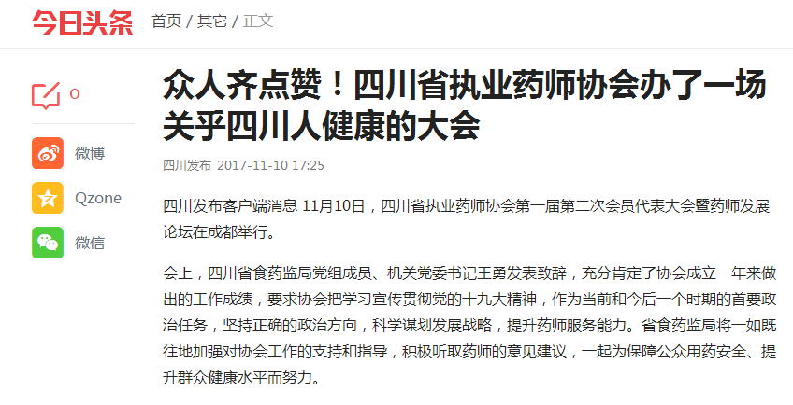
https://www.toutiao.com/i6486714671205188109/?tt_from=mobile_qq&utm_campaign=client_share&app=news_article&utm_source=mobile_qq&iid=17551695454&utm_medium=toutiao_ios
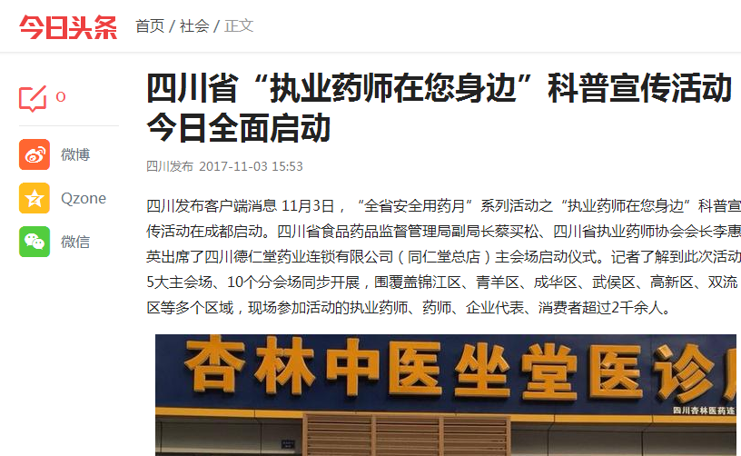
https://www.toutiao.com/i6484093341465051661/?tt_from=mobile_qq&utm_campaign=client_share&app=news_article&utm_source=mobile_qq&iid=17551695454&utm_medium=toutiao_ios

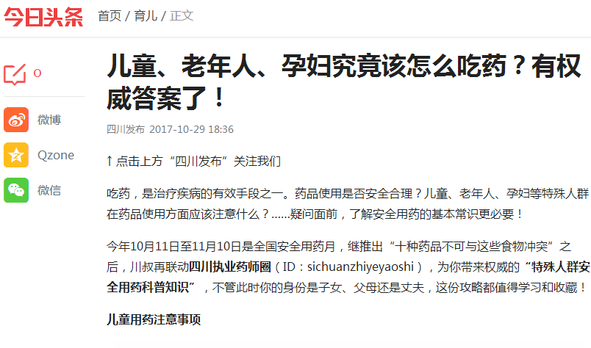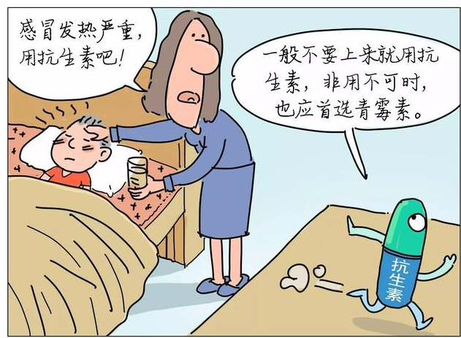
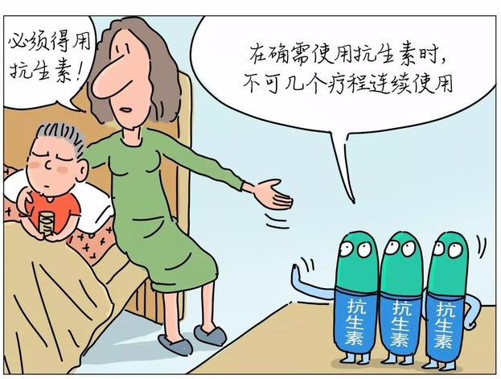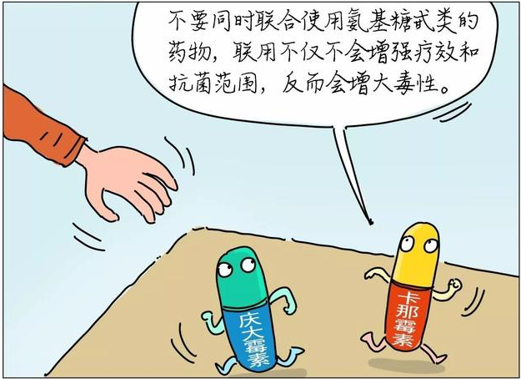
https://www.toutiao.com/i6482279829881225742/?tt_from=mobile_qq&utm_campaign=client_share&app=news_article&utm_source=mobile_qq&iid=16708527638&utm_medium=toutiao_ios
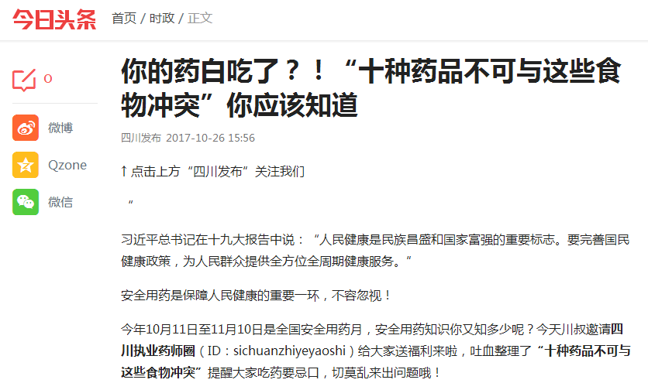
https://www.toutiao.com/i6481125328285598221/?tt_from=weixin&utm_campaign=client_share&from=singlemessage&app=news_article&utm_source=weixin&isappinstalled=0&iid=16539746401&utm_medium=toutiao_ios&wxshare_count=2&pbid=6487734296345331213
5、人民日报客户端
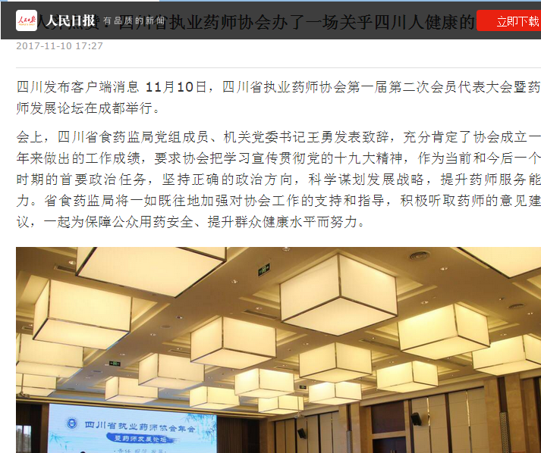
http://app.peopleapp.com/Api/600/DetailApi/shareArticle?type=2&article_id=2433881074369536

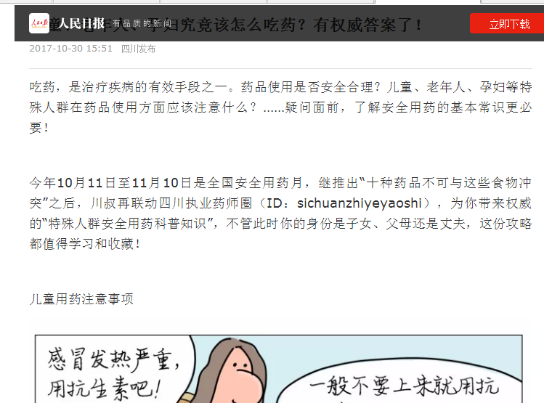
http://app.peopleapp.com/Api/600/DetailApi/shareArticle?type=2&article_id=2418215607665664
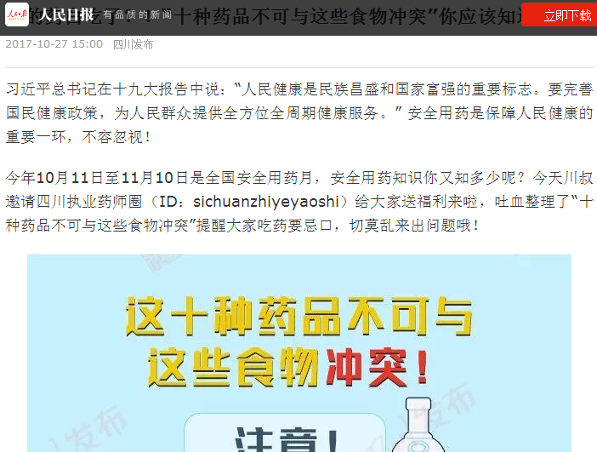
http://app.peopleapp.com/Api/600/DetailApi/shareArticle?type=2&article_id=2413918452384768&from=singlemessage&isappinstalled=0
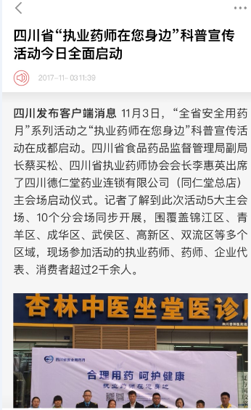
http://url.cn/5J6EDTv

6、网易
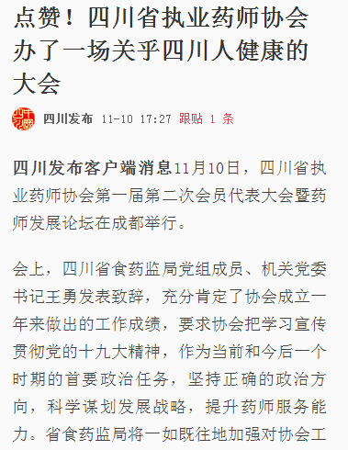
https://c.m.163.com/news/a/D2T8EOE205149O61.html?spss=newsapp&spsw=1
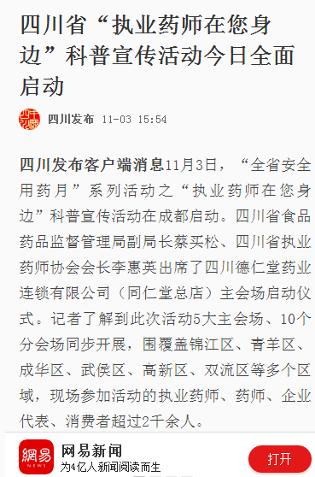
https://c.m.163.com/news/a/D2B2BTKT05149O61.html?spss=newsapp&spsw=1
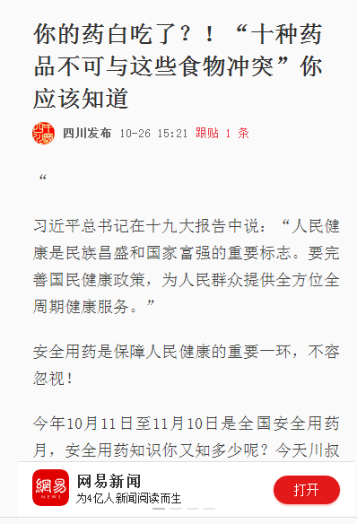
https://c.m.163.com/news/a/D1MD95GQ05149O61.html?spss=newsapp&spsw=2&from=singlemessage&isappinstalled=0&spssid=ea15f3fc407065e8e5c5dc834a8d929c

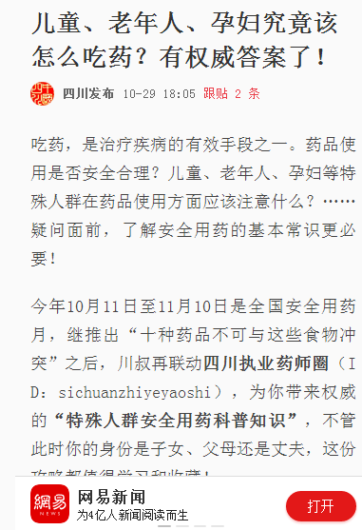
https://c.m.163.com/news/a/D1UDMJKB05149O61.html?spss=newsapp&spsw=1
7、一点资讯
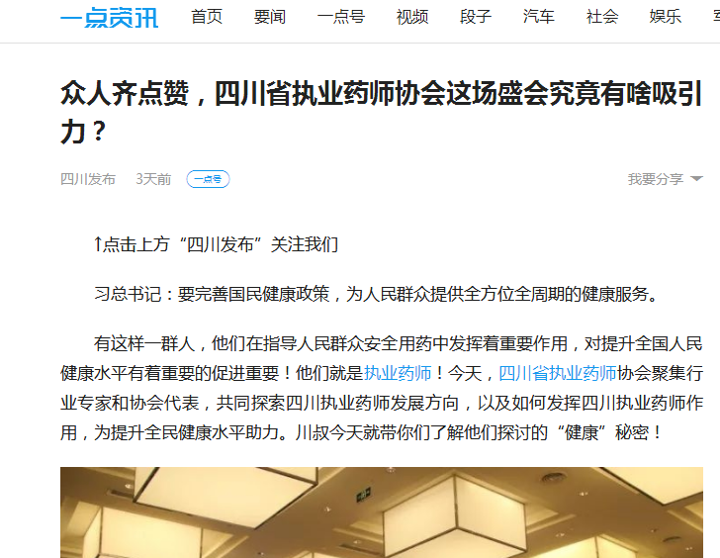
https://www.yidianzixun.com/article/0HfRgUq0?title_sn=0&yidian_dtype=1&utk=9n05mpvz&appid=pro&ver=1.1.0.2&f=ios&s=9
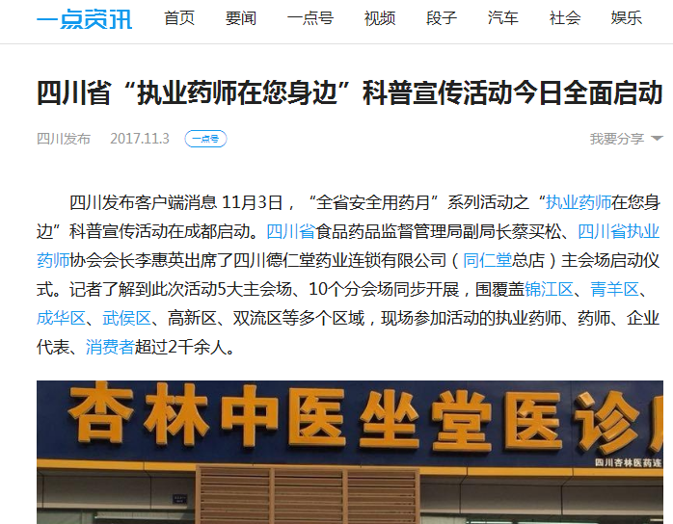
http://app.peopleapp.com/Api/600/DetailApi/shareArticle?type=2&article_id=2423880258569216&nickname=%E8%B0%AD%E7%BB%B4%E7%BB%B4&avatar=https://q.qlogo.cn/qqapp/100857255/EF090AE140F195BD48451A0835C28E87/100

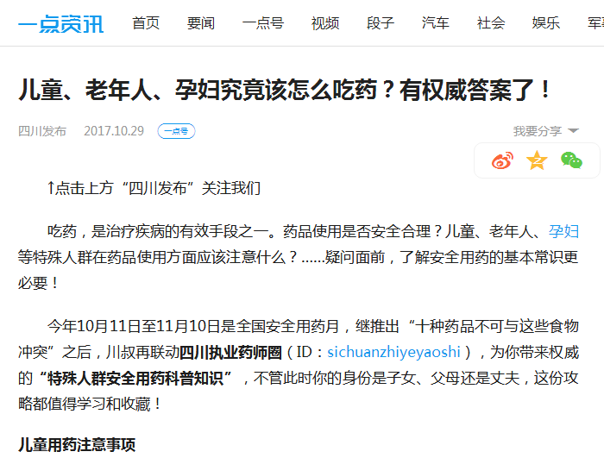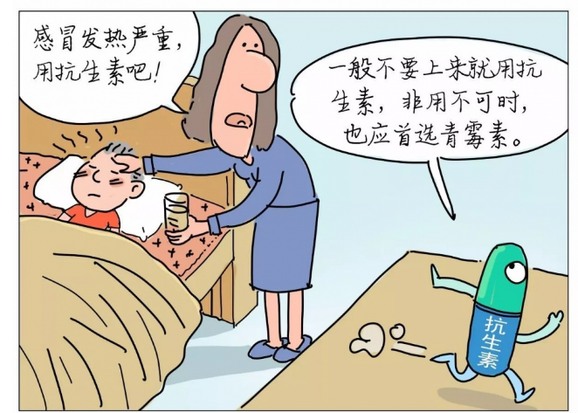

https://www.yidianzixun.com/article/0HZVXrpS?title_sn=0&yidian_dtype=1&utk=9n05mpvz&appid=pro&ver=1.0.11.1&f=ios&s=9
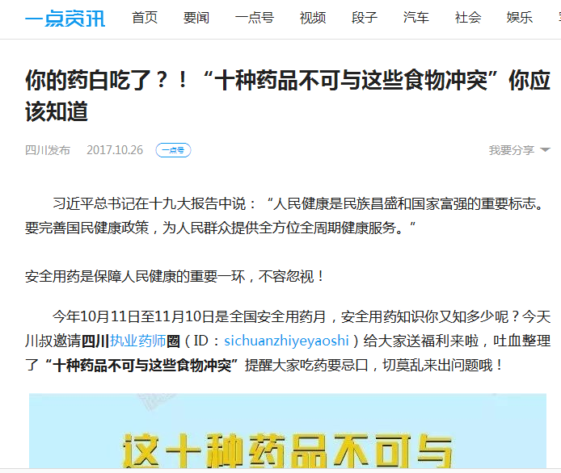
https://www.yidianzixun.com/article/0HYPXlmH?from=singlemessage&isappinstalled=0&share_count=2

8、天天快报
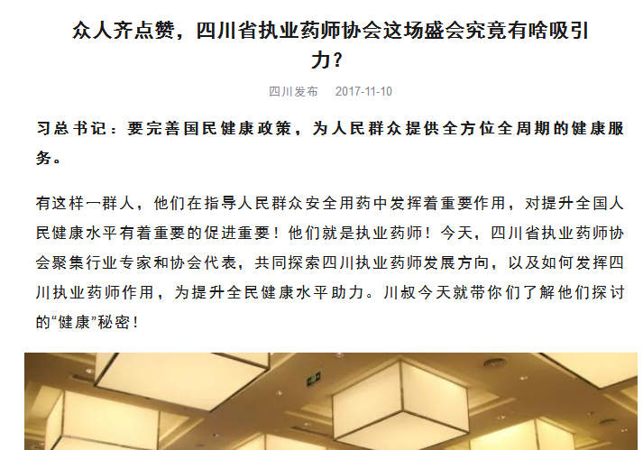
https://kuaibao.qq.com/s/20171110A0IL6200?refer=kb_news

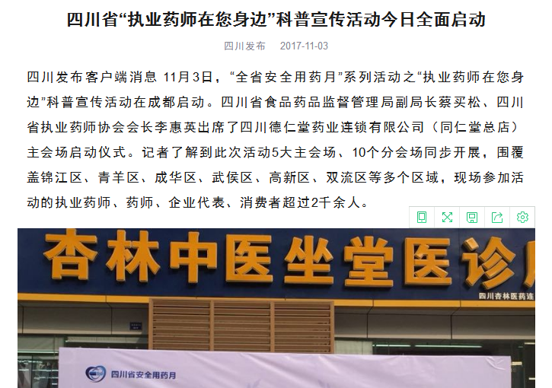
http://kuaibao.qq.com/s/20171103A0AM5A00
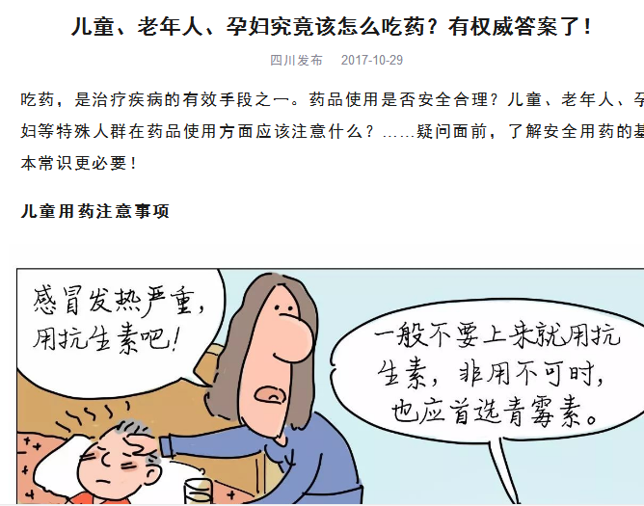
https://kuaibao.qq.com/s/20171029A07FCV00?refer=kb_news

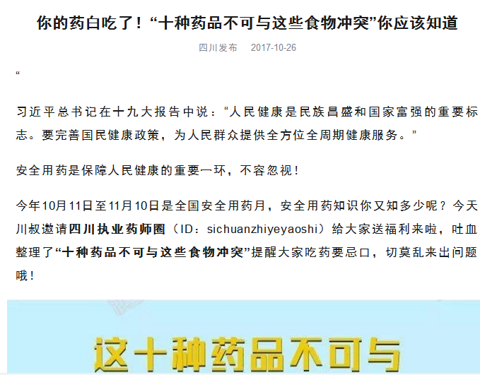
http://kuaibao.qq.com/s/20171026A08BXP00

